**ACE (Autonomous Customer Experience)**

*By*

Sheikh Abdurrehman

B20F0329SE022

Sibgha Ali Syed

B20F0434SE034

Final Year Project Report

School of Computing Sciences

Pak-Austria Fachhochschule: Institute of Applied Sciences & Technology

Spring 2024



**Pak-Austria Fachhochschule: Institute of Applied Sciences and Technology**

ACE (Autonomous Customer Experience)

A Final Year Project Report Presented to

Pak-Austria Fachhochschule: Institute of Applied Sciences and Technology

In partial fulfillment

of the requirement for the degree of

BS Software Engineering

By

Sheikh Abdurrehman

B20F0329SE022

Sibgha Ali Syed

B20F0434SE034

Spring 2024

ACE Autonomous Customer Experience

A Final Year Project Report submitted to the Department of IT and Computer Science as partial fulfillment of the requirement for the award of Degree of BS in Software Engineering.

|  |  |
| --- | --- |
| Sheikh Abdurrehman | B20F0329SE022 |
| Sibgha Ali Syed | B20F0434SE034 |

**Academic Supervisor**

Dr. Maqbool Khan

Assistant Professor School of Computing Sciences

Pak-Austria Fachhochschule: Institute of Applied Sciences and Technology

**Industry Supervisor**

Haris Ali Khan

H.O.D (Web3.0)

Swati Technologies

Lahore

**Final Approval**

**___________________________________________________**

This final year project titles

ACE Autonomous Customer Experience

By

|  |  |
| --- | --- |
| *Sheikh Abdurrehman* | *B20F0329SE022* |
| *Sibgha Ali Syed* | *B20F0434SE034* |

under the supervision of their project supervisor and approved by the project evaluation committee, has been accepted by the Pak-Austria Fachhochschule: Institute of Applied Sciences and Technology, Pakistan, in partial fulfillment of the requirements for the degree of BS Software Engineering.

Academic Supervisor: ____________________________________________________________

Dr Maqbool Khan

School Of Computing Sciences

Industry Supervisor (if applicable):

__________________________________________________________________

Haris Ali Khan

Swati Technologies DHA Phase 5 Lahore

HoD / Chairman: ____________________________________________________________________

Dr. Babar Nazir

School Of Computing Sciences

**Declaration**

We, Sheikh Abdurrehman, B20F0329SE022, Sibgha Ali Syed , B20F0434SE034 , hereby declare that we have produced the work presented in this final year project report, during the scheduled period of study. We also declare that we have not taken any material from any source except referred to wherever due to that amount of plagiarism is within an acceptable range. It is further declared that we have developed this project and the accompanied report entirely on the basis of our personal efforts made under the sincere guidance of our supervisor. No portion of the work presented in this report has been submitted in support of any other degree or qualification of this or any other University or Institute of learning, if found we shall stand responsible.

Date: May 30, 2024

Signature:__________________

**Sheikh Abdurrehman**

B20F0329SE022

Signature:__________________

**Sibgha Ali Syed**

B20F0434SE034

**Certificate**

It is certified that Sheikh Abdurrehman B20F0329SE022 , Sibgha Ali Syed have carried out all the work related to this project under my supervision at the Department of School of Computing Sciences , Pak-Austria Fachhochschule: Institute of Applied Sciences and Technology and the work fulfills the requirement for the award of BS in Software Engineering.

Date: May 30, 2024

Supervisor:

______________________________

Dr. Maqbool Khan

Assistant Professor

Head of Department:

_______________________________

Dr. Babar Nazir

Associate Professor

School of Computing Sciences

**DEDICATION**

The following work is a tribute to all those whose encouragement and help were crucial during this pursuit. In dedication to the greatest gifts any two people could ask for, a father and mother who consistently instilled in us the hope that success is attainable. With your hard-earned sacrifices and the unrelenting drive, we have been encouraged to strive for our best. To our project supervisor, Dr. Maqbool Khan Our words cannot adequately express our gratitude for your invaluable expertise, constructive criticism, and encouragement throughout this project. This is to formally acknowledge the tremendous input you have offered in your capacity as our mentor, as well as the commitment you have shown to the growth of our organization. To all our friends & fellows, and well-wishers who opened their ears and heart to listen, and/or offered their assistance in one form or the other, for their goodwill we say thank you. Your support and friendship has been invaluable to us and has provided the encouragement needed to face difficult situations as well as to rejoice in the happy ones. Lastly, our appreciation goes to all those who participated in the development, testing phases of this project in one way or the other all your comments and contributions have been far valuable in achieving our vision. To all those types of people who trusted in the idea of this project and in us, thank you for inspiring and supporting us. Thanks to you for being our companion in this journey and for being instrumental in transforming dreams into possible goals in life.

**ACKNOWLEDGMENTS**

We are deeply grateful to our academic supervisor Dr. Maqbool Khan for his invaluable advice, encouragement, and support during the course of this work. He has been very professional in his work and has provided constructive criticism in the development of the project goals and objectives.

We are also grateful to Mr. Haris Ali Khan and Hassam Ali Khan our industrial supervisor from Swati Technologies for his valuable support. His constant encouragement, support, and valuable input from the industry has been invaluable in making the project relevant to the industry.

It is my pleasure to extend my gratitude to Swati Technologies for allowing me to work on this project and to Dr. Maqbool Khan for his valuable academic support. For this collaboration, we are grateful for the experiences we had in learning, development, and practice of the theories that we encountered.

**ABSTRACT**

Real-time image recognition, video recognition, and the analysis of products on shelves via live-streaming will change the conventional approaches to tracking and identifying the products in managing inventories to be more efficient, accurate, and responsive to the needs of the customers. By trying to solve the challenges and implementing the given approach in this project, we aim at contributing to better inventory management and disseminating computer vision applications in retail and supply chain fields. In general, it can be concluded that the approach represented in the framework of this project can be used as a comprehensive, efficient, and easily implementable solution that takes into account the specifics and needs of the organization and contributes to increasing the efficiency of managing inventories and the satisfaction of customers. Additionally, the research outcomes are useful to other research studies and useful for the development of microfluidics and practical application of the similar.

Contents

1. Introduction 12

1.1 Background 13

1.2 Problem Statement 13

1.3 Motivation 14

1.4 Contributions 15

2. Literature Review 17

3. Methodology 20

**3. 1 SDLC** 21

**3. 1. 1 Requirements Gathering** 21

Functional Requirements: 21

Non-Functional Requirements: 22

**3. 1. 2 System Design** 23

UseCase Diagram: 23

Activity Diagram: 25

Class Diagram: 26

Data Flow Diagram: 27

Sequence Diagram: 30

**3.1.3 Development** 32

Data Annotation 32

Preprocessing 33

Model Training 33

Back-end Development 33

Database Integration 33

Alert Generation 33

**3.1.5 Testing** 34

**3.1.6 Deployment** 34

4.Results and Discussion 35

1. Accuracy and Efficiency of Product Detection: 36

2. Real-time Monitoring and Alerts: 36

3. User-Friendly Interface: 36

4. Scalability and Adaptability: 36

Discussion: 37

1. Impact on Operational Efficiency: 37

2. Cost-Effectiveness: 37

3. Integration with Existing Systems: 37

Challenges and Limitations: 37

Future Directions: 38

5.Conclusion 39

6. Recommendations 41

6.1 Future Work 42

6.1.1 Image Quality Optimization: 42

6.1.2 User Role Management: 42

6.1.3 Integration with Barcode/RFID Systems: 42

6.1.4 Customizable Reporting: 43

6.1.5 Real-time Alerts and Notifications: 43

6.2 Additional Recommendations 43

6.2.1 Cross-Platform Compatibility: 43

6.2.2 Interactive Visualization: 43

7. References 44

# Introduction

## 1.1 Background

It plays a major role in retail and supply chain management by providing the necessary stock that will meet the needs of the customers as they avoid holding large stocks that are costly to manage. The conventional methods of inventory tracking involve paper-based applications and records, which is cumbersome and voluminous, besides being inaccurate. These inefficiencies may result in issues such as stockouts, overstock events, hence loss of sales volume and customer loyalty. In response to these problems, automation and technology initiatives become the new option for businesses. Inventory management has various tasks that can be successfully automated using computer vision technologies belonging to artificial intelligence. With help of algorithms designed to identify and operate with visual information, businesses can enhance the management of inventory with less timing and increased efficiency and obtain the needed information on inventory status in real time. There are several object detection models available in the literature that primarily focus on the automation of the image and video analysis process, YOLO is one of them. YOLOv8 model is the improved version of base YOLO model, and it has better accuracy and performance, perfect for real time models. When using YOLOv8 in an IVMS, timely and accurate identification of products is possible, thereby facilitating timely decisions related to the products in question and inventory management. Within this context, this project proposes the use of YOLOv8 to create an automated inventory system. Machine learning for real-time analysis of images, videos, and live-streaming data of the products on shelves focuses to transform the product detection and tracking methods in inventory management processes by providing better efficiency, accuracy, and response towards the customer needs. By addressing the challenges and utilizing the proposed approach in this project, we seek to support the improvement of inventory management and the further popularization of computer vision applications in retail and supply chain industries.

## 1.2 Problem Statement

Previously traditional systems for managing inventories are used extensively, which are characterized by high rates of errors, labor-intensive and do not provide real time information. Some of the hazards include stock outs, cases where there is excess stock and a host of others due to inadequate stock control. As mentioned, the lack of systematized inventory tracking system creates demand for an accurate and precise means of managing that is responsive to the needs of operations, financially responsible, and capable of reducing the carrying costs of inventory for the business. Besides this, consumer demands are spontaneous, and the supply chain system is expansive, which makes manual inventory a very daunting task. Customers are unable to modify their orders frequently, which hinders the improvements of stock replenishment and distribution among businesses. The absence of real-time inventory tracking info creates challenges for operations decision making leading to customers not having their orders fulfilled or sales opportunities being lost. To help with these issues, there is a growing interest of using automated inventory control systems that will employ and incorporate technologies such as Computer vision and Machine learning. These systems can help with minimizing the manual processes involved in counting and improving their efficiency, as well as provide the user with live updates of the holdings. Nevertheless, the use of such systems is accompanied by certain technical peculiarities related to training and deploying such models, as well as their integration into an existing architectural framework. It can, therefore, be concluded that the primary goal of this project is to implement an automated inventory tracking system that employs the YOLOv8 object detection model. It calls for a system that will offer real time identification and location of products on shelves from image and video feeds or web cam feeds. Through use of the inventory tracking procedures the system aims at; reducing or minimizing inaccuracies, making the processes faster and more effective in responding to changes in customer demands thus leading to optimization of the inventory and satisfactory service delivery to the customers.

## 1.3 Motivation

The idea for this project arises out of the difficulties and inconveniences of provoking structural change in current inventory management systems. The conventional method of tracking inventories is usually time-consuming and involve a lot of effort, which in the end increases the chances of wrong inventory control leading to stock out, over stocking and finally unsatisfied customers. All of which are aggravated in industries where products are returned most frequently or in industries that offer a variety of different products. Also, the complexity of the supply chain and the challenges that come with the application of timely information has had the effect of suggesting that the management of inventory systems should be automated. Organizations today need tools that are able to identify the inventory levels, help to identify when demand is likely to increase, and enable ordering of the products before the demand reaches its peak, while keeping the cost of holding inventory as low as possible.

Due to the complexity of these challenges, new technologies such as computer vision and deep learning enabled by machine learning can help to meet them effectively. It shows that through the integration of models such as YOLOv8, which are effective for object recognition, we can design systems that can recognize and track products independently of a human operator in real-time.

The potential benefits of such a system are numerous: The potential benefits of such a system are numerous:

**1.Enhanced Efficiency:**

By automating the management of inventories, companies are able to save time to achieve other goals, since it regards to time-consuming tasks.

**2. Improved Accuracy:**

Machine-based approaches offer increased precisions in product detection and counting than those that involve manual processes, thus reducing the probability for stock out or overstock conditions to occur.

**3.Real-time Insights:**

The system also provides stocking level updates and issues alerts when there are indications of levels touching zero thereby allowing timely quick decisions.

**4. Scalability:**

Depending on the implementation of the entire system, it can be used in small shops, large stores, and large spaces like warehouses, which makes it a versatile option for different businesses.

In totality, this is a noble idea because the goal being pursued here is to provide the business environment with a solution that is efficient, affordable, and easily expandable in the face of contemporary day inventory management problems. Drawing on the best of current and innovative technologies our vision is to provide businesses with the right tools to work smarter and streamline their operations especially in inventory management.

## 1.4 Contributions

Our project has major impacts on the field of inventory management and the practical application of intelligent technology and deep learning methodology by building an innovative smart system based on the YOLOv8 object detection model. Firstly, it tackles issues linked to failures and inaccuracies inherent in conventional manual systems of counting inventory by offering a more sustainable system that automates and identifies products on shelves. such that real-time object detection is accurate and consistent with input media, including single images, video streams, and live cam feeds, using adapted YOLOv8 model. Moreover, the use of this model through Streamlit web application framework makes it easier for any business organization to easily operate the system it will provide by monitoring their inventory level through the interface of the system.

This is accomplished by not only being able to display the current pieces held for each product but to also display the counts dynamically and provide for real-time alerts, when the count reaches the set threshold, so that replenishment can be achieved before stockouts or unpredictable amounts are stockpiled. In this paper we present the use and benefits of an inventory tracking and management system, where real-time information will assist businesses in managing their inventory more efficiently. Moreover, the proposed project is presented as easily scalable and extensible, suggesting that it could be applied across a wide range of retail contexts that range from simple storefront shops to huge warehouses. In general, it is possible to conclude that presented in the framework of this project approach offers a comprehensive, practical, and easily scalable solution that improves organizational effectiveness of managing inventories with a positive impact on the overall performance of the business and customer satisfaction.

# Literature Review

We don’t focus on the problems that occur with traditional inventory tracking techniques and instead, we use elements such as computer vision and object detection to achieve an effective solution. Using YOLOv8 object detection model, we aim at creating a system which will ensure the firms with fast and convenient inventory tracking solution for monitoring the quantity state of the products located on the shelves.

Computer Vision and Object Detection: Some of the previous researches have looked at methods that are based on computer vision where information relating to object detection has been considered. These models include but not limited to YOLO You Only Look Once for instance, believes to have high accuracy in detecting and localizing objects from images and videos. Such models are real-time which makes it ideal to be applied in tracking inventory in changing retail markets models.

Real-Time Inventory Monitoring: Some works have provided solutions that address the issue of monitoring the stocks in order to reduce the time taken. These systems can fully synchronize with live video feeds using the object detection algorithms or RFID technology, and provide real-time updates on the product counts and real-time location of products, which helps in taking the right decisions regarding restocking of products and optimization of existing inventories.

Integration with Business Systems: Research has also stressed on a need to have integrated automated inventory management systems with other current business systems as ERP & POS. Integration and automation of data transmission they clearly make them interdependent promoting smooth performance of inventory and sales in relation to the supply chain.

Scalability and Adaptability: Various aspects of automated inventory management and its scalability and other features has also presented in the literature. Studies have been conducted touching on issues to do with the flexibility of several categories of products, different shelf arrangements and the several store conditions. Consequently, flexible and adaptable systems and interfaces can be easily implemented and adapted to function in different business environments for the handling of various aspects of business operations.

Challenges and Future Directions: However, there are some issues that are still to be addressed, such as model stability, expansiveness, and the use of coupons and offers that leads to breach the privacy of the customers. There are several opportunities for future research: enhancing the model’s capabilities to work in real-world environments; creating protocols for the exchange of visual information between systems; as well as the challenges of protecting the confidentiality and integrity of such information in its application.

In conclusion, the literature presented in this paper points to the theorem that automated inventory management systems are capable of a substantial positive impact on the improvement of operational performance and reduction of costs, as well as quality of services to customers. Using machine learning in inventory management systems provides a better solution by incorporating computer vision systems to overcome these drawbacks to fit the modern retail and supply chain requirements.

# Methodology

# 

The progress of the inventory monitoring system module of ACE is accomplished through an iterative and agile approach, which enables the establishment of applicability, timely delivery, and continuous enhancements.

The methodology consists of the following key phases:

**3. 1 SDLC**

Sourcing strategy can also be defined as the identification of the right sourcing model to use in a particular software development process, which can be described by the acronym SDLC, which stands for software development life cycle. Thus, we followed all necessary phases of SDLC in this project.

The phases which we followed are given below:

**3. 1. 1 Requirements Gathering**

* Requirements were gathered by the company from the client Jalal sons representative.
* Then we got the requirements from company , there was a member of Ai team in swati Technologies who elaborated all the requirements of the system .
* We created user stories to understand what the functional requirements of the system like monitoring of products will be and updating inventory records etc. , similarly the non-functional requirements like the model confidence and performance of systems.

### Functional Requirements:

**FR1:**The camera should monitor the products on shelves.

**FR2:**The system should detect the products on shelves.

**FR3:** The system should identify the products.

**FR4:** The system should Count the number of each product on the shelf.

**FR5:**The system should Generate alert on reaching product threshold.

### Non-Functional Requirements:

**Performance Requirements**

* Detection Speed: It is also important that the system should be able to locate the products on the shelves within a maximum of one second per frame.
* Throughput: The system should be capable of capturing and analyzing at least 1 FPS for each video stream as required in surveillance.

**Reliability Requirements:**

* Accuracy: Based on the findings of this report, the YOLOv8 model should sustain an object detection efficiency of not less than 65% under normal lighting conditions.
* Error Handling: The system should be able to address failures like lost camera feed or no connection to the database and prompt the user with an appropriate message and attempt to reconnect.

**Usability Requirements**

* User Interface: The Streamlit interface should be user friendly; the users should be able to switch from one function such as live monitoring, video detection and even inventory counting with ease**.**

**3. 1. 2 System Design**

* After the gathering of the requirements, we have made the design for the system in which we made UML diagrams to understand the system architecture and functionalities.

Following are the UML diagrams of the system architecture

1. Use case diagram
2. Activity Diagram
3. Class Diagram
4. Data Flow Diagram
5. Sequence Diagram

### UseCase Diagram:

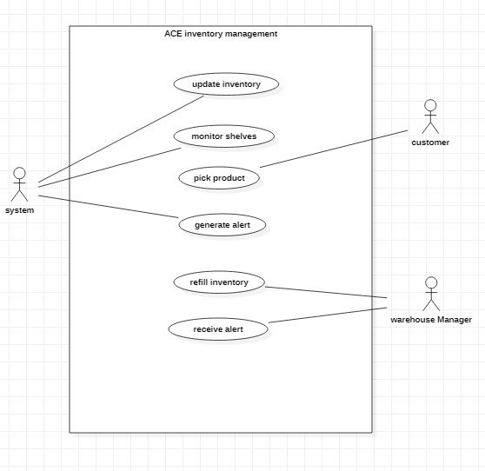

1UseCase Diagram

**Description:**

The ACE (Autonomous Customer Experience) Inventory Management system is designed to streamline and automate inventory processes in a retail environment. It involves various interactions between the system, customers, and warehouse managers.

**System:** The central actor responsible for updating inventory, monitoring shelves, assisting customers in picking products, and generating alerts when necessary. The system ensures that inventory levels are always optimal and that products are available for customers.

**Customer:** Interacts with the system to locate and pick products from the shelves. This interaction enhances the customer experience by providing real-time information about product availability and location.

**Warehouse Manager:** Receives alerts generated by the system and refills inventory accordingly. This actor ensures that the physical inventory is maintained as per the system's recommendations and alerts.

### Activity Diagram:

**2**.Activity Diagram

**Description:**The activity diagram illustrates the process of monitoring inventory levels, detecting changes, updating the database, checking inventory levels, and generating alerts when necessary. This automated system ensures that inventory levels are maintained efficiently to prevent stockouts and optimize inventory management.

### Class Diagram:

3. Class Diagram

**Description:**

The class diagram effectively models the components and interactions of the inventory monitoring system. Here’s a detailed breakdown of each class and their interactions:

**Camera:** The Camera module is involved in taking pictures of the shelves and identifying the products from the pictures. It transmits information about the identified products to the Database. Some of the important attributes that are part of this class are cameraID, location and resolution which are used to distinguish and manage the camera.

**Database:** The Database is the component of the system that is responsible for storing and managing inventory items. It has a variable (itemList) that contains information about the items in the inventory and has methods for updating the information (updateItem ()) and querying the information (queryItem()). The Database is crucial in the functioning of the system as it communicates with both, the Camera and the Alert System in order to provide appropriate identification and tracking of the inventory.

**Inventory:** The Inventory class contains general data of the inventory items; each item has a productID, a shelfID, and the current quantity. It includes methods to update the quantity (updateQuantity(newQuantity: The quantity is an integer, and it can be checked by the checkThreshold(): Boolean function. This class is useful in handling product details and the quantities to be produced for a particular product.

**Alert System:** Alert System is a mechanism that generates an alert whenever the inventory quantity is below a certain value known as alertThreshold. It contains functions for creating an alert (generateAlert()), and for notification (sendNotification()). This class makes sure that any low stock is detected and acted on immediately by informing the appropriate persons.

### Data Flow Diagram:

4. Data Flow Diagram

**Description:**

This data flow diagram is a clear representation of the entire inventory monitoring and management system and the various interactions and data exchanges involved. Each of them has its own purpose, and all of them are aimed at achieving the general goal of keeping records of maintaining and updating the inventory.

**Camera:**

The Camera is actually a real-time image of the product shelves. This raw data is very important for the other stages of the analysis.

**Captures & Analyzes Product:**

This process entails the evaluation of the captured images to identify products and determine the quantities of the products. The outcome of this process is product data that is organized and stored in the “Products Data” database for later use.

**Products Data:**

The analyzed data is stored in the “Products Data” repository so that it can be used in the inventory update process.

**Updates Inventory:**

This process helps to update the inventory database with the new details of the products, thus the database will have the real-time information on the products that are on the shelves.

**Database:**

The major component “Database” is the central location where all the inventory data is stored. It works with a number of processes to ensure that inventory records are correct and are regularly updated.

**Inventory Level Check:**

This process compares the existing stock with a set of parameters to determine if it needs replenishment. When the levels go down to this point, it leads to other actions to deal with the inventory.

**Inventory Update:**

Subsequently, this process changes the inventory levels in the database to reflect the current status of the inventory in the warehouse.

**Threshold Check:**

The “Threshold Check” process validates whether the inventory is at its lowest point. If so, it prompts the alert system to notify the appropriate individuals.

**Alert System:**

This system produces signals to the management whenever the inventory of the products is depleted to the recommended minimum level, thus, indicating that the quantities need to be restocked.

### Sequence Diagram:

5. Sequence Diagram

Description:

The sequence diagram provides a clear and structured flow of activities involved in the inventory monitoring and restocking process. Each participant plays a crucial role in ensuring that inventory levels are maintained, and products are restocked promptly.

**Camera:**

The Camera initiates the process by capturing real-time images or videos of the product shelves. This step is crucial for collecting accurate data on the inventory levels.

**Computer Vision System:**

The Computer Vision System processes the captured data to detect and count the products. This system uses image recognition algorithms to analyze the product images and determine the quantities available. It then sends the processed data to the Inventory Management System.

**Inventory Management System:**

The Inventory Management System is responsible for checking the received product data against the inventory thresholds. If any product is found to be below the threshold, the system generates a notification to alert the store staff. The system also updates the inventory levels once the products are restocked, ensuring accurate record-keeping.

**Store Staff:**

The Store Staff receive notifications from the Inventory Management System indicating which products need to be restocked. They are responsible for physically replenishing the shelves and ensuring that the inventory levels are maintained.

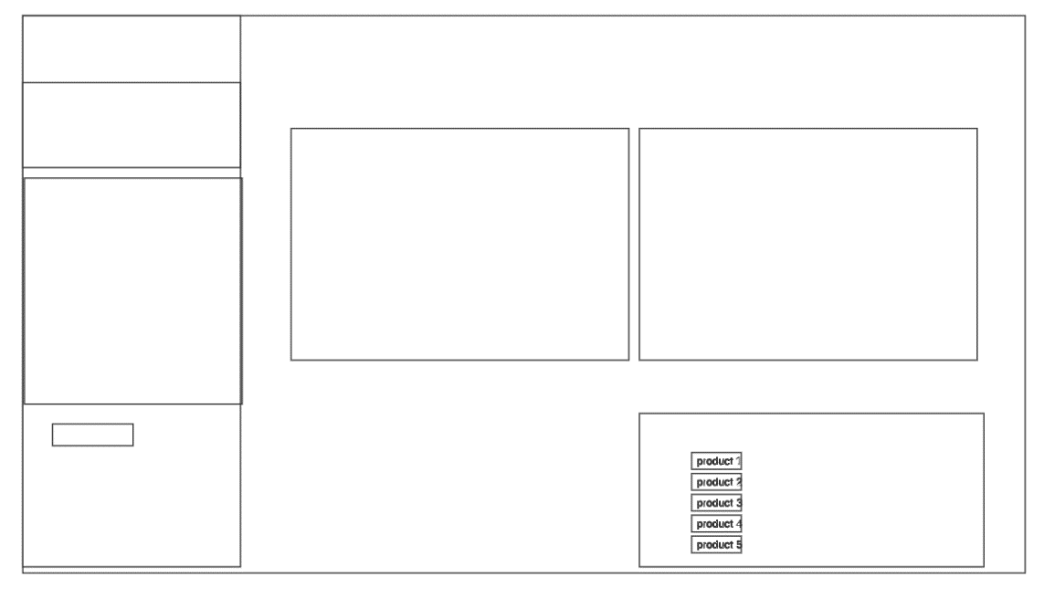

6. wire frame

For the front end of the system we created some wireframes to visualize how interface will look like.

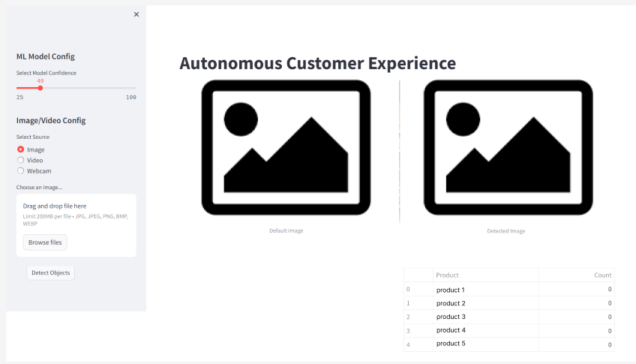

7. UI Design

* Designed the database schema to store and get products data and easily update.

**3.1.3 Development**

The development of the inventory monitoring system followed a comprehensive process starting from data extraction, annotation, and preprocessing to model training and implementation. Key components and steps are detailed below:

**Data Extraction**

* Initiated the project by collecting images of products from physical stores and multiple online sources.
* Utilized web scraping techniques and manual data collection to gather comprehensive image datasets.

### Data Annotation

* Uploaded the collected images to Roboflow for annotation.
* Carefully annotated the data to accurately label the products, ensuring precise training of the model.

### Preprocessing

* Applied preprocessing techniques to enhance the quality and consistency of the data:
* Auto-Orient: Ensured all images were correctly oriented.
* Resize: Stretched images to a uniform size of 640x640 pixels.
* Applied data augmentation to increase the diversity of the training dataset:
* Outputs per Training Example: Generated 3 variations of each image.
* Brightness: Adjusted brightness levels between -15% and +15%.
* Exposure: Modified exposure levels between -7% and +7%.
* Noise: Added noise to up to 0.69% of pixels to simulate real-world variations.

**Dataset Export**

* Exported the preprocessed and augmented dataset from Roboflow, preparing it for the training phase.

### Model Training

* Trained the inventory monitoring model using YOLOv8 for accurate product detection and tracking.
* Utilized the annotated and preprocessed dataset to train the model, ensuring it could accurately identify and track inventory items in real-time.

### Back-end Development

* Developed the back-end of the system using Python.
* Implemented efficient data processing and business logic components to handle real-time inventory updates and alert generation.

**Front-end Development**

* Utilized Streamlit to create an intuitive and interactive user interface for store staff and warehouse managers.
* Ensured the design was responsive, providing optimal user interfaces across different devices.

### Database Integration

* Employed SQLite3 for efficient data storage and retrieval.
* Designed the database schema to support real-time inventory updates and alert generation.

### Alert Generation

* Implemented robust alert mechanisms to notify warehouse managers when product quantities fell below predefined thresholds.
* Ensured alerts were timely and actionable, enabling prompt replenishment of inventory.

**3.1.5 Testing**

* I conducted thorough testing at multiple levels, including unit testing for individual components, integration testing for combined modules, and system testing for the entire application.
* Performed usability testing to ensure the user interface was intuitive and met the needs of store staff and warehouse managers.
* Implemented a thorough testing and debugging process to identify and resolve any issues, ensuring the system was reliable and performed well under various conditions.

**3.1.6 Deployment**

* Created a repository on Github and uploaded the project to share with the company.

Verified that all functionalities were working

# 4.Results and Discussion

ACE project has produced a number of positive outcomes once the automated inventory management has been successfully set out. The work integrated the YOLOv8 object detection ML model into a Streamlit web appliaction to turnout, track, and manage products’ inventories in realtime. Key results from the project include Key results from the project include:

## 1. Accuracy and Efficiency of Product Detection:

They found that the YOLOv8 model had high accuracy while detecting and identifying the array of the products on shelves. In Testing phase, the model was able to get an object detection efficiency of more thatn 65% under normal lighting. This performance metric is critical in tracking the inventory since it helps avoid cases of stockouts or conditions where organizations are overstocked with unsalable goods.

## 2. Real-time Monitoring and Alerts:

To this extent, the system had the capacity to give real-time information of the stocks in the store. Whenever the number of products hit certain pre-established levels triggering the existence of alerts, the founders were immediately notified enabling them to restock and avert numerous hiccups in their supply chain systems.

## 3. User-Friendly Interface:

The strong side of the Streamlit web application was on the fact that it offered user-friendly and interactive interfaces. Employees may also be able to quickly transition between utilising the systems for tasks like watching the store in real-time, detecting abnormal movements through filmed video, and counting the products in the warehouse. A usability aspect that was explored extensively in this evaluation was the user experience of this system as the extent of ease in accessibility was confirmed.

## 4. Scalability and Adaptability:

When comparing the effectiveness of the system in the different scenarios it was found that the modular nature of the system made it possible to be used in any type of retail business starting from a small shop to a large warehouse. A key strength of the system has been showcased in its flexibility that allows it to be implemented on different scales and settings, hence making it very useful in any business environment.

## Discussion:

The development and deployment of the ACE project underscored several critical insights and implications for the future of automated inventory management: The development and deployment of the ACE project underscored several critical insights and implications for the future of automated inventory management:

## 1. Impact on Operational Efficiency:

This paper argues that through the integration of automated means of tracking inventories in organizations, enhance the operations of such organizations. This means that staff that would the former be spending valuable work hours counting inventories can now be more productive on other tasks.

## 2. Cost-Effectiveness:

The automated inventory management system can then empower a business with an inexpensive means of tracking and reducing possible inaccuracies in the automotive spare part stock. After defining overstock and stockout costs, it becomes clear that the automated approach of demand forecasting saves businesses millions of dollars, facilitating better financial results.

## 3. Integration with Existing Systems:

At the current level, the project reached the stages of providing such functions as work with inventory in automatic mode, whereas future prospects could include expanding the connection with various business applications, including ERP (Enterprise Resource Planning) and POS (Point of Sale) systems. Whereas if inventory management functions as a module of the larger enterprise system, there would be better coordination, making processes even more efficient than they already are, hence better inventory management.

## Challenges and Limitations:

While analyzing the process, it is possible to point out several strengths and weaknesses, as well as several challenges that have taken place during the project. Another challenge was to enhance the model’s performance in recognizing photographs taken with variations in lighting and books piled up on shelves. Besides, to maintain the real-time processing capability, while the system was extended for larger environment, several of the platform issues were encountered.

One limitation arose from this changed position in that data annotation and model training occurred too frequently to accommodate continual changes in the inventory and product placements. It can be concluded that the accomplishment of these objectives is possible only through the intensive funding of research and development to enhance the performance and reliability of the system.

## Future Directions:

Some possible further development of this work can include more elaborate optimization of image quality or illumination that changes with environmental perceptions and noise. From the pictures the authors stated that implementing role-based access control and incorporating bar code/RFID technological platform may enhance security and performance.

In addition to it, as current reporting is possible with some flexibility then improving the real-time alert related to the business metrics by using email or even an SMS would be helpful for the businesses since the general and direct information regarding business would be provided to them.

Finally, enhancing the compatibility to enable the porting of the system to other platforms & enhancing the interactivity & visually integrated components of the system will ensure that the system is more appropriate to meet the demands of the new world business. Conclusively, if all the crucial aspects are considered and the results of the ACE project are evaluated, then it is possible to state that the implementation of the technological features such as Computer Vision and Machine Learning for inventory management. Thus, focusing on the identified problems and building upon the progress that has been already made, the system may develop into a valuable asset for any enterprise in a quest of improving its inventories management capabilities and, moreover, clients’ satisfaction.

# 5.Conclusion

For the ACE project, we developed an efficient and automated method to track inventories by utilizing the YOLOv8 model and the Streamlit web application. Thus, this new system of tracking inventory is much better than this traditional method in terms of time and efficiency.

* The main achievements include:
* These are likely to be high accuracy in finding and counting the products.
* Automated tracking of inventory levels and generating notifications when necessary.
* A user-friendly interface.

They facilitate business operations, lead to cost-cutting measures, and make the customers content. The use of the system can be applied in various retail platforms such as limited storerooms, shops, and even big garages.

The possible enhancements can be made to the equipment include enhanced image quality, enhanced security of user access, and capabilities to integrate with bar code or radio frequency identification code systems. Real-time notification through the various communication channels and the ability to generate custom reports will make the system even better.

Using the ACE project, it is possible to effectively see how the application of advance technologies can help enhance inventory management. Thus, by overcoming current difficulties and expanding upon existing developments, this system can migrate to the sphere of beneficial use for enterprises. They also have the added benefit of being much cheaper and more effective when it comes to managing the stock, with helping to ensure that today’s business thrives.

# Recommendations

Based on the completion of this project and the insights gained throughout its development, several recommendations can be made to further enhance the system's functionality and effectiveness:Based on the completion of this project and the insights gained throughout its development, several recommendations can be made to further enhance the system's functionality and effectiveness:.

# Future Work

## Image Quality Optimization:

To make the system more powerful to handle the different quality images, they need to implement the new technological image processing solutions. It can include the magnification of the picture, filtering of any noise, image enlarging to contrast the object and applying other algorithms to ensure that the product is detected even in low light or dusty environments.

## User Role Management:

It is necessary to implement the role-based access control system in the application’s functionality. It also enables different users to have distinct access and control levels depending on their roles, thus providing added security to inventory data and maintaining the integrity of the information stored by ensuring that only authorized users are allowed access to vital information.

.

## Integration with Barcode/RFID Systems:

It uses an effective model of implementing visual detection together with the most commonly used barcode and RFID scanning. This combination may enhance the inventory measures to be efficient and fast and in environments which may be tough for the visual detection of objects because of occlusions or low lighting conditions.

## Customizable Reporting:

Design integrated reporting, which will enable the user to create reports on either the inventory turnover rates, shrinkage or whichever other indices deemed relevant by the system. With this, decision-making and inventory management could be enhanced since businesses would be able to make decisions based on trends and projections.

## Real-time Alerts and Notifications:

Improve the alerting model for generating real-time notifications for persons of interest through channels such as email, SMS, or mobile push. This ensures that any important changes to the stocks held are communicated promptly to everyone of interest, so that he or she can take appropriate measures.

# Additional Recommendations

## Cross-Platform Compatibility:

Make sure that the system can run the code on various operating systems and on different types of devices, such as PCs, tablets, and smartphones. This cross-platform compatibility can make inventory management easier than before – more accessible and versatile for businesspeople who are frequently on the go.

## Interactive Visualization:

Addition to basic metrics, enrich the dashboard with advanced UI widgets like the heat maps, trends, and more detailed drill charts. These tools can assist users in terms of achieving enhanced visibility to their inventory data or find patterns that are useful in some way.

# References

**Ultralytics. (2023).** YOLOv8 Documentation. Retrieved from <https://docs.ultralytics.com/yolov8>

**Roboflow. (2023).** Annotation and Preprocessing in Computer Vision. Retrieved from <https://blog.roboflow.com/annotation>

**Streamlit. (2023).** Streamlit Documentation. Retrieved from

<https://docs.streamlit.io>